**BLOCK DIAGRAM ON CHATBOT WITH WATSON.**

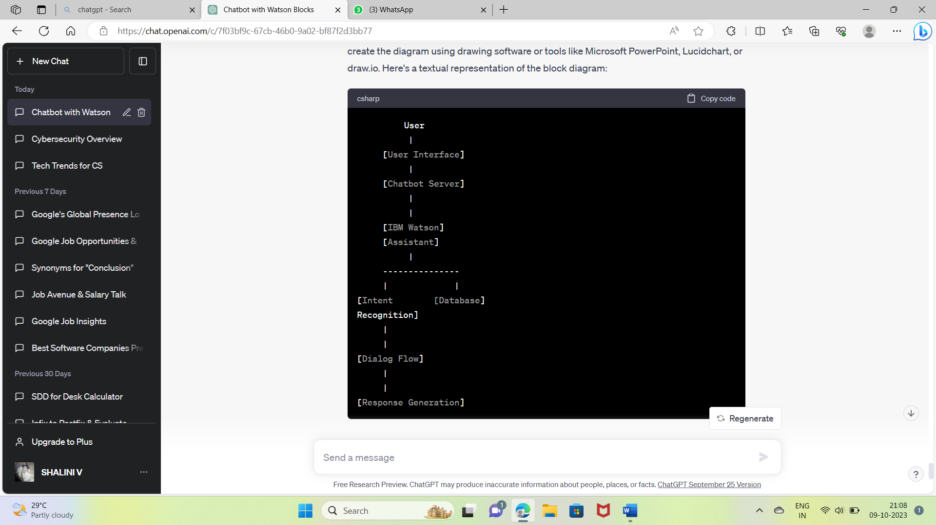

**DATASET USED AND THEIR PROPERTIES.**

**1. Intentions**

Description: Intentions refer to a user's objective or purpose during a communication. Every purpose relates to a distinct user desire that the chatbot must comprehend.

Aspects:

Name: The intent's special identification.

Examples: A collection of illustrative user messages related to the intent. The chatbot can learn to understand different forms of intent thanks to these examples.

**2. Illustrations of Intents**

Description: A collection of sample user messages is linked to each intent. These illustrations show different ways in which users could convey the same intention.

Aspects:

Text: The example user message's real text.

Intent: The intention with which this example is connected.

**3. Entities**

Description: Entities stand in for particular bits of data that the chatbot needs to gather from user input. They provide the discourse with context.

Aspects:

Name: The entity's special identification number.

Values: Alternative names or potential values for the entity.

Examples: Phrases that show how to mention the entity in user communications.

**4.Entity Values**

Description: Users may refer to each entity by one of a set of possible values or synonyms.

Aspects:

Value: The true value or equivalent.

Alternative ways for users to convey the same value are known as "synonyms."

**5. Dialog nodes**

Description: Dialog nodes control how the chatbot responds to user input and govern the flow of the conversation.

Aspects:

Conditions: Requirements that cause the dialog node to execute.

Responses: Comments made by the chatbot in relation to the dialog node.

Actions: Any steps the chatbot should do before, during, or after the execution of the node.

**6. User Data**

Description: A dataset containing user profiles and preferences may be utilized if the chatbot wants to customise responses or store user-specific information.

Aspects:

User ID: Each user's individual identification number.

Additional characteristics, depending on the needs, such as *Name, Preferences, etc.*.

**7. Optional System Entities**

Description: For typical notions like dates, times, and numbers, Watson Assistant provides system entities. If your chatbot needs to understand and interact with these ideas, you can use them.

Aspects:

Type: the nature of the system element, such as "@sys-date."

**8. Training Data Quality Metrics**

Description: To evaluate the effectiveness of the chatbot, certain projects may add metrics relating to the caliber of the training data.

Aspects:

Precision, Recall, F1 Score: Metrics used to gauge how well the intent recognition model is doing.

**PREPROCESSING.**

**1.Lowercase Text:**

Lowercase the entire text. As Watson Assistant is by default case-insensitive, this helps to ensure consistency in the identification of intents and entities.

**2.Tokenization:**

The user's input was divided up into separate words or tokens. Since Watson Assistant only processes individual tokens, tokenization makes it simpler to examine and interpret the language.

**3.Stop Word Elimination:**

Remove frequent terms that are regarded as stop words (such as "and," "the," and "in") because they have little significance and can be safely left out of analysis. As a result, the text is less noisy.

**4.Lemmatization or Stemming :**

Words should be reduced to their root or base form. Stemming and lemmatization help to recognize intent by considering several word forms as one word.

**5.Spelling and grammar check:**

Use a spell checker to fix frequent spelling mistakes in user input. This guarantees proper recognition of entities and intents.

**6.Normalization:**

Substitute standardized forms for synonyms to normalize text. In this case, "2nite" might be changed to "tonight."

**7.Remove all punctuation and special characters:**

Remove any symbols, punctuation, or other special characters that don't help the reader grasp the message. This makes text analysis easier.

**8.Extracting Entities :**

Entity recognition may need to be implemented as part of preprocessing if your chatbot project calls for a particular type of entity recognition, such as extracting dates, places, or product names.

**9.** **How to Use Emoticons and Emojis:**

Emojis and emoticons can be handled by either deleting them or interpreting them for sentiment analysis, depending on the use case for your chatbot.

**10.Detection of Language:**

Find out the user's input language, especially if your chatbot supports various languages. Using the appropriate language models to understand the content is made easier by language detection.

**FEATURE EXTRACTIONS.**

**1.Messages from Users as Features:**

The key components for deciphering user intent and context are user messages, which stand in for the user's input.

Intent, entities, and context are all extracted from these communications by Watson Assistant during analysis.

**2.Desired Qualities:**

A key component is the extracted intent. It displays the user's intention or objective for the chat.

The chatbot uses intent features to decide precisely how to react to user inquiries.

**3.Features of Entities:**

Entities (such as dates, places, and product names) represent particular bits of information that users enter.

The chatbot can access and utilise pertinent data from user communications thanks to extracted entities, which are crucial features.

**4.Contextual Details:**

Contextual elements include the chatbot's conversational memory. Maintaining cohesive and context-aware interactions depends on this context.

The chatbot benefits from being able to recall prior user communications and its own responses.

**5.Flow of Dialog Features:**

Information about the conversation's current status, such as active dialog nodes and conditions, is included in dialog flow features.

These elements direct the chatbot's response production, ensuring that it adheres to the desired conversational flow.

**6.Entities of the System:**

System entities are provided by Watson Assistant for everyday ideas like dates, times, and numbers. If your chatbot needs to operate with these ideas, they can be thought of as supplemental functionality.

**7.User Profile Information:**

You can leverage user profile information from a database to customize answers and include user-specific features.

**8.Analysis of Sentiment:**

To extract sentiment-related information from user messages, sentiment analysis can be done as a preprocessing step.

These options reveal details regarding the emotional undertone of the user's input.

**9.Customized Additional Features**

You may incorporate unique features like domain-specific flags, business rules, or contextual data depending on the particular needs of your chatbot.

**10.Quality Metrics for Training Data:**

In some projects, the success of the intent recognition model may be evaluated using measures related to the caliber of the training data, such as precision, recall, or F1 score.

**MODULE AND IT’S DESCRIPTION:**

**1.Customer Interface:**

This module represents the user interface that allows users to communicate with the chatbot. Users input their messages and receive responses through an interface, which can be a website, mobile app, messaging platform, or any other type of interface.

**2. Chatbot Server:**

Purpose: The chatbot server is in charge of taking in and handling user communications. Between the user interface and the IBM Watson Assistant service, it serves as a bridge. It responds to user inquiries that come in, preprocesses them if necessary, and then delivers them to Watson Assistant for evaluation.

**3. IBM Watson Assistant:**

The main part of Watson Assistant is in charge of deciphering user input and producing responses. It carries out natural language understanding (NLU) tasks, such as entity extraction (finding specific information) and intent recognition (finding the user's intention).

**4. Dialog Flow:**

Dialogue flow describes how a discussion is structured and how a chatbot reacts to user input. The chatbot's actions throughout the conversation are controlled by a set of rules, circumstances, and replies that are included. The Watson Assistant controls the dialogue flow.

**5. Context Management:**

To keep the discourse in an appropriate condition, context management is essential. It enables context-aware interactions and coherent discussions by assisting the chatbot in remembering prior user messages and its own responses.

**6. Integration with External Systems:**

To perform tasks other than giving information, many chatbots must communicate with external systems, databases, APIs, or services. This module manages the integration, enabling the chatbot to use external data or services and access them.

**7.User Data Management:**

Information about users' preferences and profiles is kept in a database in some chatbot initiatives. This module controls user data and offers personalisation features, enabling the chatbot to adjust responses in accordance with user data.

**8. Webhooks:**

In order to transmit data between the chatbot and other services or systems in real-time, webhooks are employed. They allow the chatbot to send commands to or receive updates from external systems.

**9. Analytics and Reporting:**

This module gathers and examines information on user behavior, performance metrics, and chatbot interactions. It offers information that may be used to enhance the user experience and efficacy of the chatbot.

**10.Authentication and Security:**

Only authorized users can access specific features or data because security modules manage user authentication and authorisation. Additionally, they enforce privacy and data protection regulations.